SIMATS ENGINEERING
ASSESSMENT TOOL 3: Reverse Engineering Task

COURSE NAME: Cloud Computing and
Big Data Analytics

COURSE CODE: CSA15

COURSE OUTCOME COVERED
CO4: Analyze big data characteristics and challenges across domains including security and application aspects.
(BL4)
Assessment Tool Weightage: 10%
Dave&#39;s Taxonomy: Articulation (Level 4)
Question Count: 5

Total Marks: 30

Code of Conduct
I _Arthi Reddy(192565054) (Name / Reg No) certify that this submission is my original work and that I have adhered
to the guidelines specified for this assessment.
I understand that any violation of academic integrity rules will result in disciplinary action.
Signature of the student: ____________________
Assessment Tasks
Reverse Engineering Task
For each task, study the described big data solution, infer how it was built, identify the underlying components, and
explain what design decisions were likely made.
1. A recommendation engine processes user clicks, search queries, and purchases from multiple devices. Reverse
engineer the probable data types, ingestion flow, and analytics stages.
2. A ride-sharing company displays live traffic heatmaps and demand forecasts. Reverse engineer the likely
distributed storage and processing backbone behind the system.
3. A fraud detection dashboard flags suspicious card transactions in near real time. Reverse engineer the probable
big data security, streaming, and alerting mechanisms used.
4. A social media platform stores videos, text comments, hashtags, and user engagement metrics. Reverse
engineer how structured and unstructured data are probably managed together.
5. A manufacturing IoT platform collects machine logs and maintenance events from many plants. Reverse
engineer the likely integration tools, storage strategy, and analytics path.

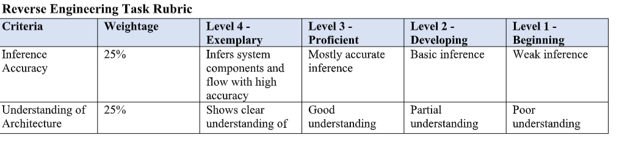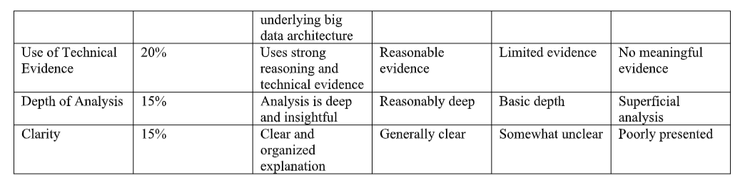
Big Data – Reverse Engineering Case Study Answers
1. Recommendation Engine
Probable Data Types
- Structured: User IDs, purchase records, product IDs.
- Semi-structured: Search queries, clickstream logs, JSON data.
- Unstructured: Reviews, images, and other user-generated content.
Ingestion Flow
Multiple Devices → Data Collection → Kafka/Streaming → Data Lake → Processing
Analytics Stages
- Collect user clicks, searches, and purchases.
- Clean and integrate the data.
- Create user behavior profiles.
- Apply recommendation algorithms.
- Generate personalized product recommendations.
- Continuously update recommendations using new user activity.
Probable Technologies
- Kafka → Data ingestion
- Data Lake/HDFS → Storage
- Spark → Data processing
- Machine Learning → Recommendation
Conclusion
The system most likely uses a real-time data pipeline combined with machine learning to provide personalized recommendations.

2. Ride-Sharing Live Traffic and Demand Forecasting
Probable Data Sources
- GPS locations of vehicles.
- Ride requests.
- Driver locations.
- Traffic sensors.
- Historical trip data.
Distributed Storage
A distributed data lake or HDFS/cloud object storage is likely used to store massive historical location and trip data.
Processing Backbone
GPS/Sensor Data → Kafka → Distributed Storage → Spark → Analytics → Live Dashboard
Real-Time Processing
Streaming systems process current vehicle and traffic information to generate live heatmaps.
Batch Processing
Historical trip data is processed to identify:
- Peak travel times.
- High-demand areas.
- Traffic patterns.
Machine Learning
Demand forecasting models predict where and when more drivers will be required.
Conclusion
The system likely combines distributed storage, real-time stream processing, batch analytics, and machine learning.

3. Fraud Detection Dashboard
Data Sources
- Card transactions.
- Customer accounts.
- Transaction locations.
- Merchant information.
- Historical transaction records.
Streaming Mechanism
Transaction → Kafka/Streaming Platform → Stream Processing → Fraud Detection Model
Transactions are processed continuously to detect suspicious activity.
Security Mechanisms
1. Encryption
Protects transaction data during storage and transmission.
2. Authentication
Ensures only authorized users and systems can access the platform.
3. Access Control
Restricts access to sensitive financial information.
4. Audit Logs
Records user activities and system events.
Alerting Mechanism
When a transaction is identified as suspicious:
Fraud Model → Alert System → Dashboard/Security Team
Analytics
Machine learning can identify patterns such as:
- Unusual transaction amounts.
- Multiple transactions in a short period.
- Unusual locations.
- Abnormal spending behavior.
Conclusion
The system likely uses secure streaming, real-time analytics, machine learning, and automated alerts.

4. Social Media Data Management
Structured Data
Examples:
- User ID.
- Post ID.
- Likes.
- Shares.
- Followers.
- Engagement counts.
This data can be stored in relational or NoSQL databases.
Unstructured Data
Examples:
- Videos.
- Images.
- Text comments.
- Audio.
These can be stored in a distributed file system or cloud object storage.
Semi-Structured Data
Examples:
- Hashtags.
- JSON-based post metadata.
- Application logs.
These can be stored in a data lake or NoSQL database.
Probable Architecture
Users → Data Ingestion → Data Lake + Databases → Processing → Analytics
Analytics
The platform can analyze:
- Trending hashtags.
- User engagement.
- Popular videos.
- Content recommendations.
- User behavior.
Conclusion
The platform likely uses a hybrid architecture, combining databases for structured information with distributed/object storage for large unstructured content.

5. Manufacturing IoT Platform
Data Sources
- Machine sensors.
- Machine logs.
- Maintenance records.
- Temperature and vibration data.
- Production information.
Integration Tools
- IoT gateways collect machine data.
- MQTT can transmit sensor messages.
- Kafka can handle high-volume streaming data.
- ETL/integration tools combine data from different plants.
Storage Strategy
Real-Time Data
Stored and processed using streaming platforms for immediate monitoring.
Historical Data
Stored in a data lake/distributed storage for long-term analysis.
Analytics Path
Machines → IoT Gateway → MQTT/Kafka → Data Lake → Spark → Machine Learning → Dashboard
Analytics Applications
- Predictive maintenance.
- Machine failure prediction.
- Production optimization.
- Anomaly detection.
- Equipment performance monitoring.
Conclusion
The manufacturing platform likely combines IoT integration, streaming ingestion, distributed storage, real-time processing, and machine learning to monitor machines and predict failures.

